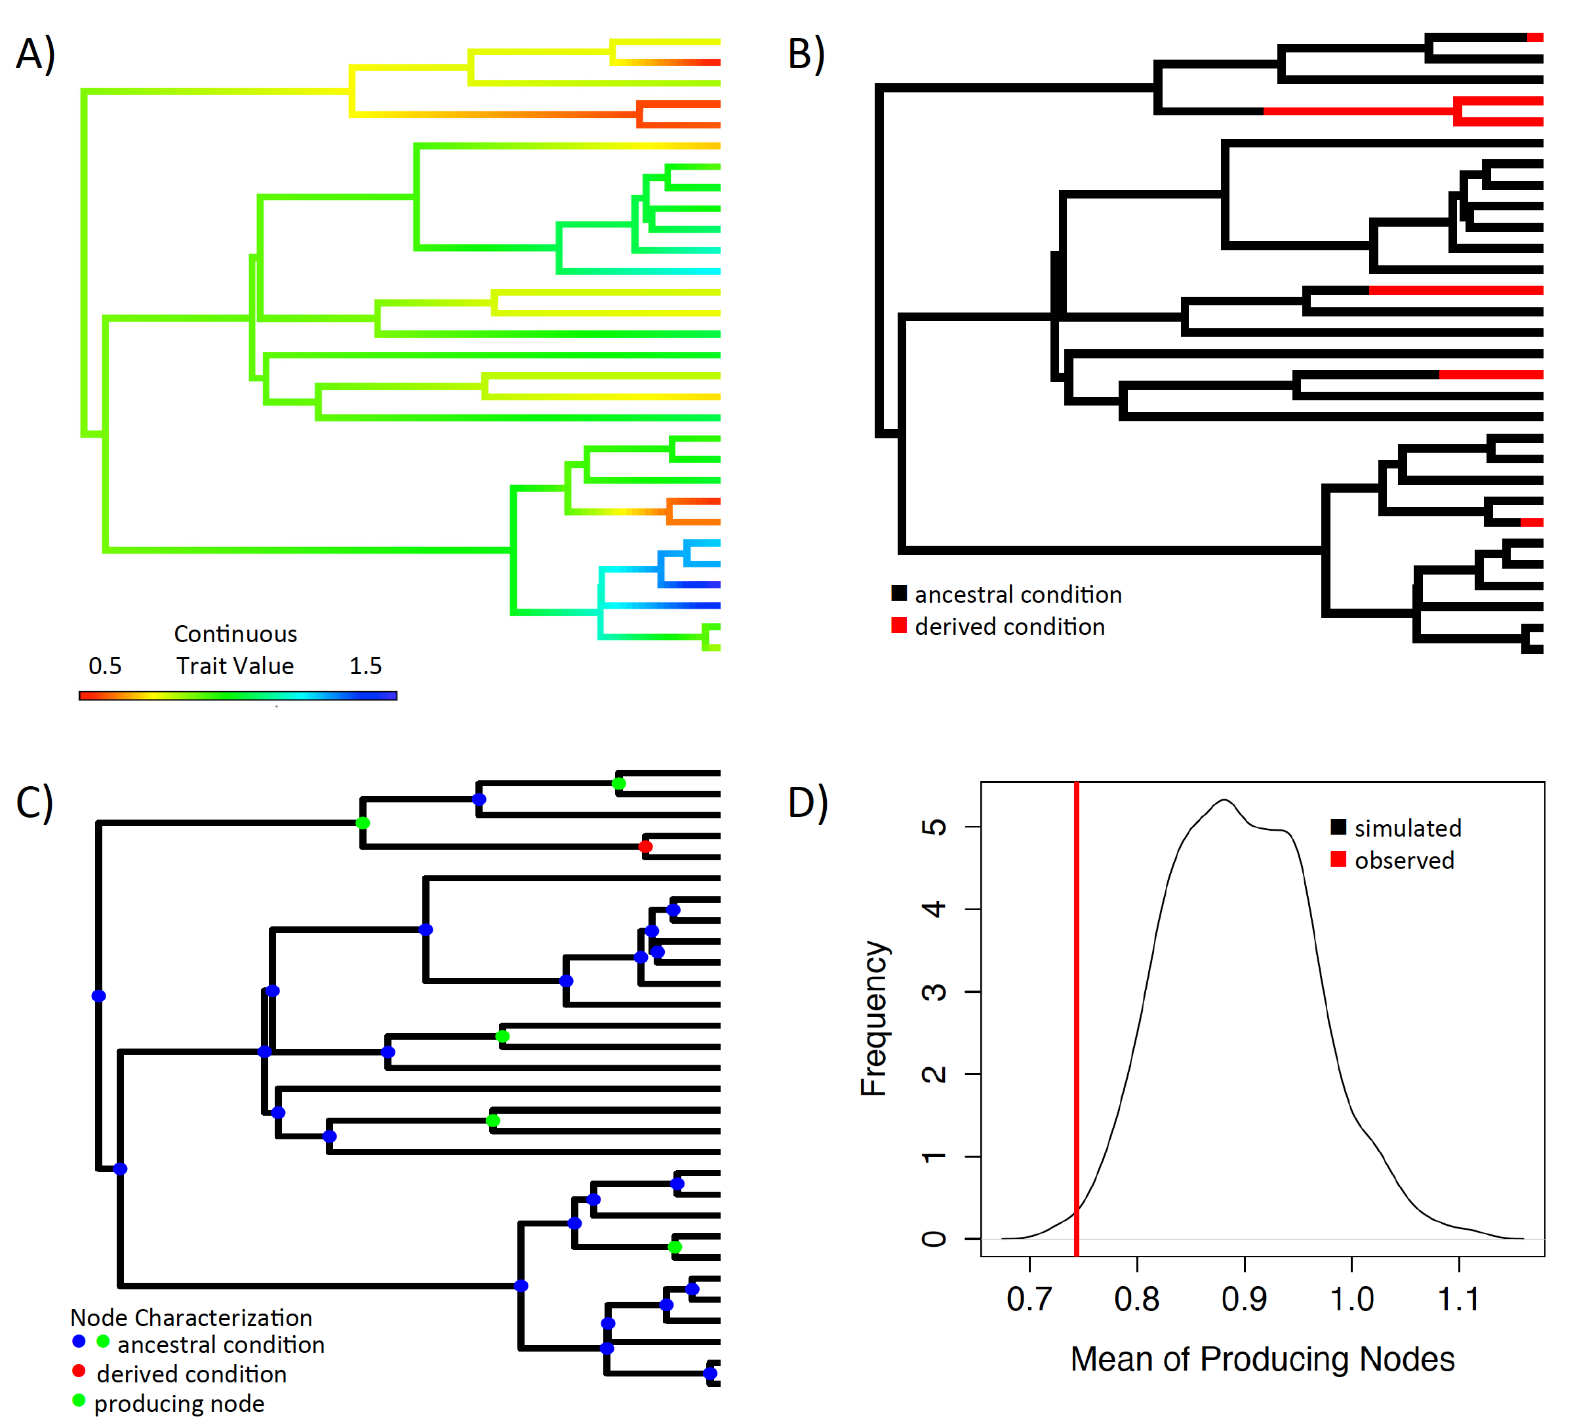

**Figure 1. Four steps in the ancestral condition test.** A) Ancestral state reconstruction of continuous character assuming a Brownian motion model of evolution. B) Identification of the transition points in the discrete character through stochastic mapping C) Categorization of nodes as either ancestral or derived as well as those that subtend an origin of the derived state of the discrete character. D) Depiction of the null distribution and the observed mean of producing nodes estimate from the data. In this example the producing nodes have a lower continuous value than expected if there is no relationship between the traits.

Untitled:Users:demuthlab:Desktop:Copy:anc.cond:figures:basic.eps

**Figure 2** P-values from the analysis of simulated datasets with various scaling factors. The X-axis indicates the scaling factor used to stretch trees with a value of one indicating no relationship and a value of 10 indicating the strongest relationship. The values at the top of the plot indicate the percentage of simulated datasets that resulted in significant results under our test. Each column contains the results of 200 tests.

Untitled:Users:demuthlab:Desktop:Copy:anc.cond:figures:taxa.eps

**Figure 3** P-values from analysis of simulated datasets with various numbers of taxa. The X-axis indicates the number of taxa present in a dataset while the Y-axis indicates the p-value generated from each test. The values at the top of the plot indicate the percentage of simulated datasets that resulted in significant results under our test. Each column contains the results of 100 tests.